This insert includes supplemental information for model P250AF DI(N,LP)-E and P265F BB DIN-E burners with an electrical enclosure. Refer to the manual for additional installation instructions, troubleshooting, and other important information.

Parts list
Part number | Description | Qty Required
64388-001 | Motor/Blower Asm | 1
64377-001 | Control box | 1
64378-001 | Control box lid | 1
64379-001 | Control box inner plate | 1
63592-003 | Terminal block | 2
64411-002 | Ignition wire | 1
64410-001 | Wire Harness w/Sense wire | 1
64395-001 | Ignition control | 1
These parts are specific to burners with an electrical enclosure. Parts listed here can be used on both P250 and P265 burners. For spare parts not specific to enclosed burners, see section VI of the manual.
Wiring instructions
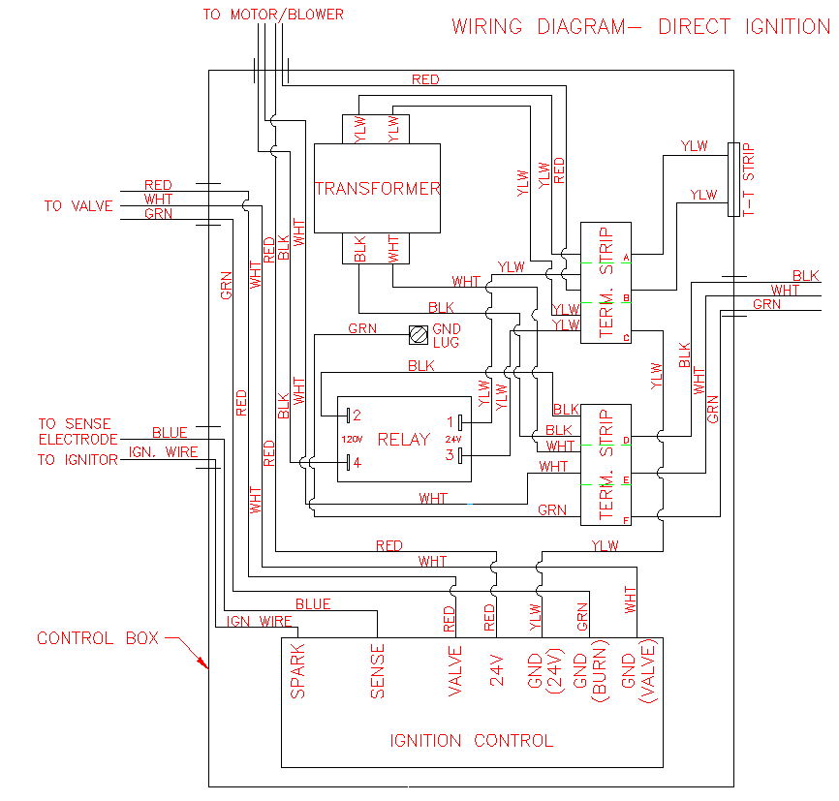
Connect to 120 Vac line voltage here. These wires to be supplied by installer.
Connect the burner to 120 V power as shown by feeding supply wires through the hole on the right side of the enclosure to the lower terminal block. Instructions for making good connections with the terminal blocks can be found on the opposite page.
Connecting to terminal blocks
To connect a wire to the terminal block, strip ¼” of insulation from the end of the wire, then insert it into one of the connection holes while applying firm pressure on the tab nearest to it. Release the tab when the wire is in, then tug the wire to confirm a good connection. Voltage may be tested at each node by probing the holes between the tabs.
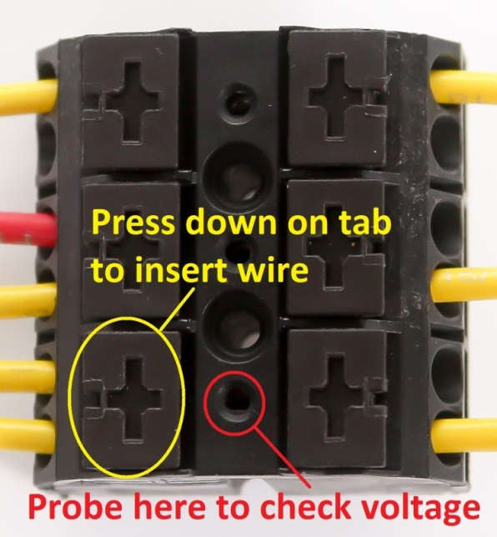
A closeup of a 63592-003 terminal block. Ports are connected in pairs on each side. Each pair is also connected to the pair on the opposite side.
Sequence of operation
On a call for heat, the ignition control’s diagnostic LED will start to flash green at a rate of about twice per second. After the prepurge time, it will flash rapidly while the ignition control begins sparking. After successful ignition, the LED will light green and remain lit as long as a flame is detected. If the burner fails to light, the control will wait for the interpurge time, then spark again. If this happens three times, the ignition control will be locked out, and the diagnostic LED will flash red. If this happens, remove power from the control, then try again. The number of LED flashes indicates the type of failure that occurred (see table below). If the burner lights, but loses flame, the ignition control will attempt to relight immediately without a purge.

Number of flashes | Problem
1 | No flame during trial for ignition
2 | Flame sense fail
3 | Gas valve relay failure
4 | Multiple flame loss
7 | Input voltage error

Prepurge time | 30 seconds
Trial for ignition | 4 seconds
Interpurge time | 30 seconds

